**November 2015 CSA Spotlight Award Winner – Deb Michel**

Deb Michel has been employed with ECC for 4 years. She began on 9/12/11 as an Accounting Clerk. She is currently working as the Cashier in Accounts Receivable.

She enjoys walking and spending time with her grandchildren. Some of her favorite things include the color, blue; dark chocolate; pumpkin spice; red, delicious apples and making healthy choices with her foods.

When not concentrating on “all of the above”, she enjoys resale shops and watching “Criminal Minds” or Hallmark movies on the television.

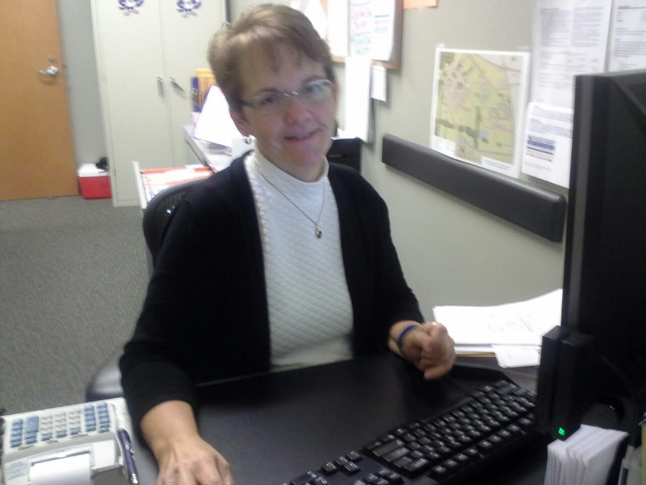 The college is fortunate to have a devoted, hard-working employee such as Deb. Congratulations!