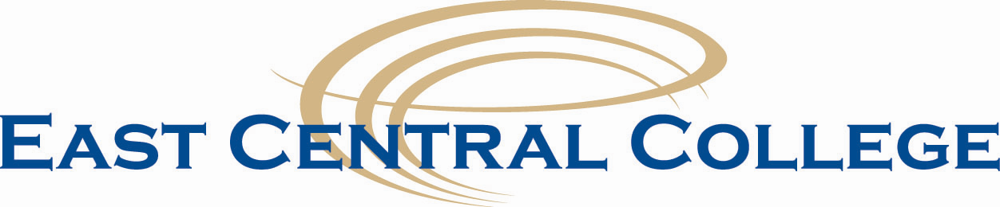

Human Resources Interoffice Memo

2018 Holiday Schedule

The College will be closed on the following days in accordance with the Board Policy:

New Year’s Day Monday, January 1

Martin Luther King, Jr. Day Monday, January 15

Good Friday Friday, March 30

Floating Holiday Friday, May 25

Memorial Day Monday, May 28

Independence Day Wednesday, July 4

Labor Day Monday, September 3

Thanksgiving Break Wednesday, November 21 - Friday, November 23

Christmas Break Thursday, December 20 – Monday, December 31

Approved.

