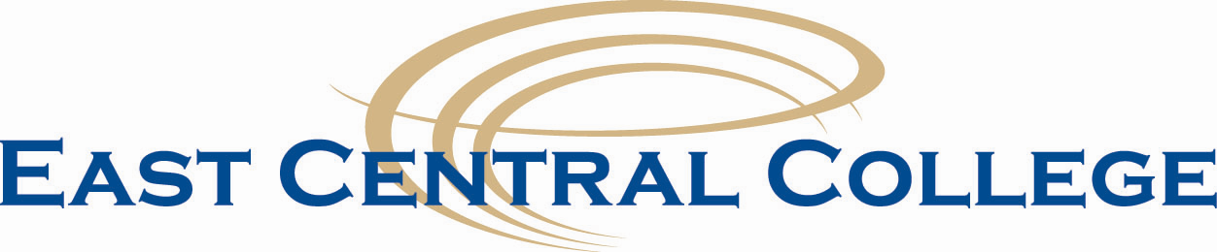

Human Resources Interoffice Memo

2019 Holiday Schedule

The College will be closed on the following days in accordance with the Board Policy:

New Year’s Day Tuesday, January 1

Martin Luther King, Jr. Day Monday, January 21

Spring Break March 18 – March 23

Good Friday Friday, April 19

Memorial Day Monday, May 27

Independence Day Thursday, July 4

Floating Holiday Friday, July 5

Labor Day Monday, September 2

Fall Break October 10 – 12

Thanksgiving Break Wednesday, November 27 - Friday, November 29

Christmas Break Thursday, December 19 – Tuesday, December 31

Approved 2-27-18
Updated 12-12-18

