Precalculus -- Trig Review for the Final Exam

An equation with a restriction on x is given. This is the equation of the terminal side of an angle θ in standard position. Sketch the smallest positive such angle θ, and use your sketch to find the values of the indicated trigonometric functions. Rationalize denominators when applicable.

1)

3x - y = 0, x ≥ 0Find tan θ and cot θ.

Answer the question.

2)

What central angle (in radians) corresponds to an arc length of 10 yd and a radius of 11 yd? Round to the nearest hundredth of a radian.

Convert the angle to decimal degrees and round to the nearest hundredth of a degree.

3)

Convert the angle to radians. Leave as a multiple of π.

4)

324°

Convert the radian measure to degrees.

5)

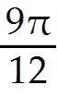

Decide in what quadrant the point corresponding to s must lie to satisfy the following conditions for s.

6)

,

Decide whether the statement is possible or impossible.

7)

8)

9)

Determine the value of the trigonometric function of s using the given information.

10)

, Find .

Determine what fraction of the circumference of the unit circle the value represents.

11)

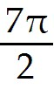

Draw the given angle in standard position. Draw an arrow representing the correct amount of rotation. Find the measure of two other angles, one positive and one negative, coterminal with the given angle.

12)

10°

Express the given trigonometric function in terms of the indicated function.

13)

cos θ in terms of csc θ

Find the angle of least positive measure that is coterminal with the given angle.

14)

Find the exact value of the indicated part in the figure.

15)

Find b.

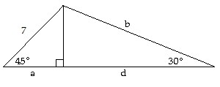

Find the function value. If it is undefined, say so.

16)

17)

Find the measure of each angle in the problem.

18)

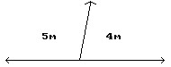

Find the reference angle for the given angle.

19)

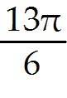

Find the specified quantity.

20)

Find the range of .

21)

Find the period of .

22)

Find the phase shift of .

23)

Find the vertical translation of .

24)

Find the phase shift of .

25)

Find the range of .

26)

Find the amplitude of .

Find the trigonometric function value of angle θ. Use a calculator if necessary.

27)

, with θ in quadrant IV
Find tan θ.

Give an expression that generates all angles coterminal with the given angle. Let n represent any integer.

28)

-109°

Give the exact value.

29)

30)

Graph the function over a one-period interval.

31)

Graph the function.

32)

33)

34)

35)

36)

37)

Identify the quadrant for the angle θ satisfying the following conditions.

38)

and

If n is an integer, represents an integer multiple of 180°, andrepresents an odd integer multiple of . Decide whether the expression is equal to 0, 1, -1, or is undefined.

39)

cos((2n + 1) ∙ 90°)

Perform the calculation.

40)

Sketch an angle θ in standard position such that θ has the smallest positive measure and the given point is on the terminal side of θ.

41)

(-2, 5)

Solve the problem.

42)

From a boat on the river below a dam, the angle of elevation to the top of the dam is If the dam is 2239 feet above the level of the river, how far is the boat from the base of the dam (to the nearest foot)?

43)

A rotating beacon is located 4 ft from a wall. If the distance from the beacon to the point on the wall where the beacon is aimed is given by , where t is in seconds, find a when t = 0.38 seconds. Round your answer to the nearest hundredth.

44)

The voltage E in an electrical circuit is given by , where t is time measured in seconds. Find the period.

45)

Find the area of the work space for a robotic arm that can rotate between -15° and 45° and can change its length from 6 inches to 21 inches. Round to one decimal place.

46)

Two pulleys of diameter 9 m and 3 m are connected by a belt. The larger pulley rotates 33 times per minute. Find the angular speed of the smaller pulley.

47)

A car wheel has a 16-inch radius. Through what angle (to the nearest tenth of a degree) does the wheel turn when the car rolls forward 3 ft?

48)

Find the complement of an angle whose measure is .

Solve the right triangle.

49)

B = 26.6°, c = 4.2 mm, C = 90°

50)

a = 1.3 in., A = 49.8°, C = 90°

Suppose that θ is in standard position and the given point is on the terminal side of θ. Give the exact value of the indicated trig function for θ.

51)

( 7, 9); Find cot θ.

52)

( -20, 48); Find sin θ.

Find the value of x or y, as appropriate. Assume the ordered pair is located on the unit circle.

53)

, x > 0

Use the appropriate identity to find the indicated function value. Rationalize the denominator, if applicable. If the given value is a decimal, round your answer to three decimal places.

54)

, if

Use the unit circle and any appropriate relationship among the trigonometric functions to find the value.

55)

56)

57)

Without using a calculator, give the exact trigonometric function value with rational denominator.

58)

59)

Write the expression in terms of its cofunction.

60)

61)

Write the function in terms of a function of the reference angle.

62)

Determine whether the equation is an identity. If it is an identity, prove it.

63)

Determine whether the equation is an identity. If it is an identity, prove it.

64)

Determine whether the equation is an identity. If it is an identity, prove it.

65)

Evaluate the expression.

66)

67)

Find the exact value of the real number y.

68)

Give the degree measure of θ.

69)

Graph the inverse function as defined in the text.

70)

Identify the equation as either an identity or not.

71)

72)

Provide an appropriate response.

73)

State the range of the inverse cotangent function.

74)

State the domain of the inverse cosine function.

Simplify the expression.

75)

Solve the equation for solutions in the interval [0, 2π).

76)

,

Solve the equation for solutions in the interval [0, 2π).

77)

78)

79)

80)

Solve the equation for solutions in the interval [0°, 360°).

81)

82)

Solve the equation for solutions in the interval [0, 2π).

83)

84)

85)

Use a half-number identity to find an exact value for the function, given the information about x.

86)

, given , with 0 < x <

Use a product-to-sum identity to rewrite the expression.

87)

Use a sum-to-product identity to rewrite the expression.

88)

Use an appropriate identity to find the exact value of the expression.

89)

90)

Use an identity to write the expression as a single trigonometric function or as a single number.

91)

92)

Use the appropriate sum or difference identity to write the given expression as a function of x alone.

93)

Use the given information to find the exact value.

94)

, 0 < A < ; , < B < 2πFind.

Write the expression as a constant, a single trigonometric function, or a power of a trigonometric function.

95)

96)

Write the expression as a trigonometric function of a positive number.

97)

98)

Determine whether the given vectors are orthogonal.

99)

and

Draw a sketch to represent the vector. Refer to the vectors pictured here.
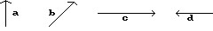

100)

-b

Estimate the indicated component or components of the vector. Round to an appropriate number of significant digits.

101)

Find the vertical component of.

Find a ∙ b.

102)

a = 7i + 7j, b = -3.5i - 3.5j

Find the angle between the given vectors to the nearest tenth of a degree.

103)

a = and b =

Find the area of the triangle using one of the area formulas.

104)

a = 10.6 cm
b = 17.1 cm
c = 16.9 cm

Find the indicated vector.

105)

Let u = . Find -9u.

Find the magnitude and direction angle (to the nearest tenth) for the given vector. Give the measure of the direction angle as an angle in [0, 360°).

106)

Find the missing parts of the triangle.

107)

A = 28°
a = 35 km
b = 47 km

108)

A = 109.2°
a = 1204 cm
b = 1304 cm

109)

A = 30.0°
a = 2.37
b = 4.74

Solve the problem.

110)

If u = and v = , evaluate (2u) ∙ v.

111)

A room in the shape of a triangle has sides of length 18.5 yd, 14.2 yd and 11.0 yd. If carpeting costs $21.86 per sq. yd, padding costs $2.00 per sq. yd, and there is no charge for installation, how much, to the nearest dollar, will it cost to carpet the room?

112)

A ship travels 62 km on a bearing of 15°, and then travels on a bearing of 105° for 119 km. Find the distance of the end of the trip from the starting point, to the nearest kilometer.

Solve the triangle.

113)

b = 8 ft, c = 9 ft, A = 115°
(Round lengths to the nearest tenth when necessary and angles to the nearest degree.)

114)

B = 34.1°
C = 101.7°
b = 36.99

Solve the triangle. Find angles to the nearest hundredth of a degree.

115)

a = 6.9 in., b = 13.3 in., c = 16.2 in.

Solve.

116)

To find the distance AB across a river, a distance BC of 643 m is laid off on one side of the river. It is found that B = 107.3° and C=14.2° Find AB.

Use the parallelogram rule to find the magnitude of the resultant force for the two forces shown in the figure. Round to one decimal place.

117)

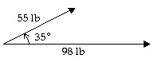

Write the vector in the form ai + bj. Round a and b to 3 decimal places if necessary.

118)

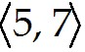

1)

tan θ = 3;

2)

0.91

3)

80.21°

4)

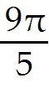

5)

135°

6)

III

7)

Possible

8)

Impossible

9)

Possible

10)

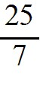

11)

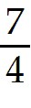

12)

370° and -350°

13)

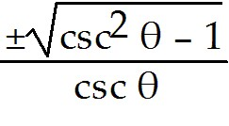

14)

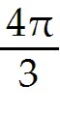

15)

b = 7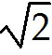

16)

1

17)

0

18)

100° and 80°

19)

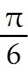

20)

(-∞, ∞)

21)

4π

22)

π to the right

23)

4

24)

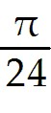

25)

[-5, 5]

26)

2

27)

28)

-109° + n ∙ 360°

29)

-

30)

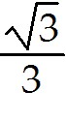

31)

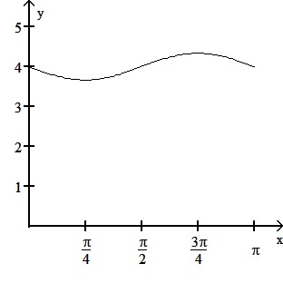

32)

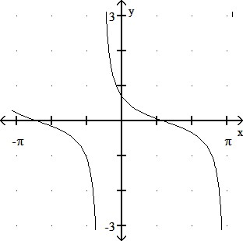

33)

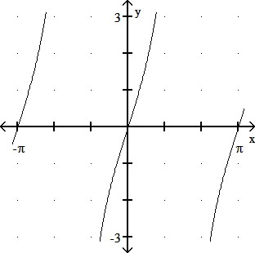

34)

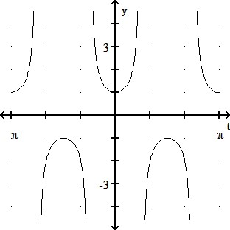

35)

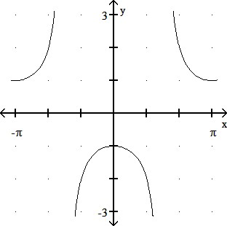

36)

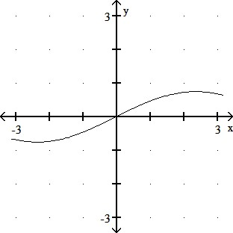

37)

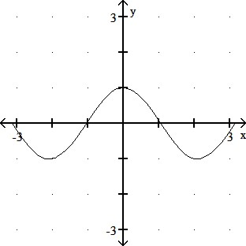

38)

Quadrant IV

39)

0

40)

28°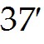

41)

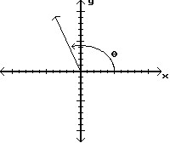

42)

5767 ft

43)

5.49 ft

44)

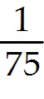

45)

212.1 square inches

46)

198π radians/min

47)

128.9°

48)

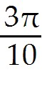

49)

a = 3.8 mm, A = 63.4°, b = 1.9 mm

50)

b = 1.1 in., B = 40.2°, c = 1.7 in.

51)

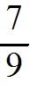

52)

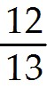

53)

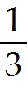

54)

55)

56)

57)

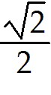

58)

1

59)

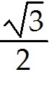

60)

sec 65°

61)

cos 11°

62)

63)

Identity

64)

Identity

65)

The statement is an identity.

66)

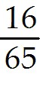

67)

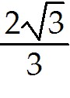

68)

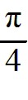

69)

30°

70)

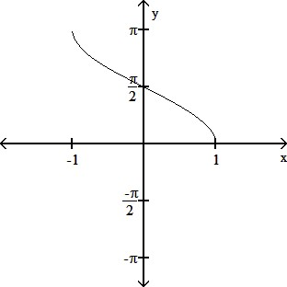

71)

Identity

72)

Identity

73)

(0, π)

74)

[-1, 1]

75)

cot x

76)

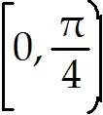 ∪ 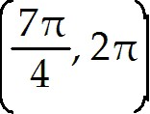

77)

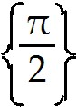

78)

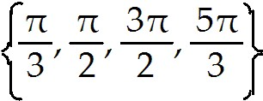

79)

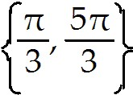

80)

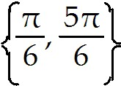

81)

{15°, 165°, 195°, 345°}

82)

{30°, 150°}

83)

{0, π}

84)

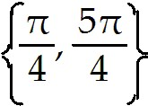

85)

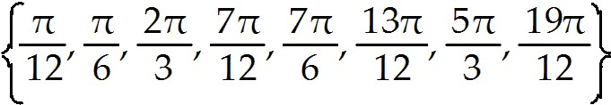

86)

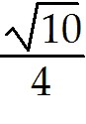

87)

0.5(cos 4t - cos 8t)

88)

2 sin 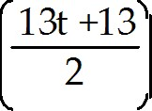 cos 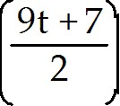

89)

90)

91)

cos 8x

92)

93)

-sin x

94)

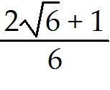

95)

sec2θ

96)

cos2 x

97)

sec 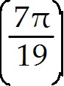

98)

-sin 8.51

99)

Yes

100)

101)

373

102)

-49

103)

12.5°

104)

86 cm2

105)

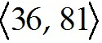

106)

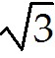; 324.7°

107)

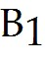 = 39°, 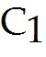 = 113°, 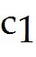 = 69 km
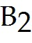 = 141°, 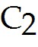 = 11°, 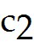 = 14 km

108)

No solution

109)

B = 90.0°, C = 60.0°, c = 4.1

110)

-34

111)

$ 1860

112)

134 km

113)

a = 14.3 ft, B = 30°, C = 35°

114)

A = 44.2°, a = 46.00, c = 64.61

115)

A = 24.63°, B = 53.45°, C = 101.92°

116)

185 m

117)

146.5 lb

118)

5i + 7j

