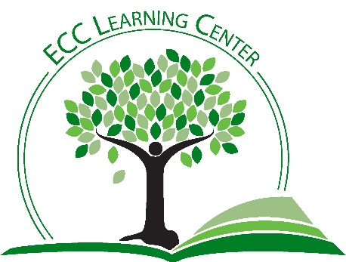

**NEW Classroom Workshops**

This year, The Learning Center is pleased to offer several **NEW** workshops that can be requested for classroom presentation. In addition, we can work with you to create workshops that are tailored to your specific pedagogical goals.

**Introduction to the Learning Center and the Testing Center**

This recently revamped overview of support services begins with a fun group activity that demonstrates the power and efficiency of some well-timed learning support.

**The Science of Success**

In this workshop, students learn how brain science can improve their study habits and chances for academic success. Students will discover how the brain changes as learning takes place, consider the natural human learning process, and discuss how this process works. They will conclude with discussion and practice of brain-friendly study techniques.

**Defeating Distractors**

In this workshop, students will begin with a self-assessment to determine their personal tendency to become bored. After the self-assessment, they will discover their personal distractors, discuss boredom busters, and practice monitoring concentration while reading.

**Memory Magic**

In this workshop, students will discover how memory works, take a memory survey, and practice some proven memory enhancing techniques.

**Mind Mapping**

Mind mapping is one of the most powerful study/learning tools because of the brain’s natural preference to view information in a non-linear way. In this workshop, students will learn about mind mapping, discover why it’s so effective, and practice creating and working with mind maps.

**Test Taking Tips and Tricks**

Students will begin this workshop with a test-taking self-assessment, followed by a discussion of proven test-taking strategies. Next, they will assess their levels of test anxiety, discover coping skills, and learn how to deal effectively with various kinds of test questions, including multiple-choice, true-false, matching and fill-in-the-blank, and essay questions. We will also discuss post-test analysis and how to recover from difficult test-taking experiences.

**Canvas Basics and Beyond**

This workshop has been designed to help students with their transition from Moodle to Canvas. We will cover the basics of setting notifications, navigating courses, communicating with instructors, and submitting assignments. There will be time for specific questions.

**What If COVID Strikes Again?**

This workshop will help students to plan for success if East Central College is forced to close its campus again due to COVID-19. Topics to be covered include communication, technology, time management, online academic support, self-care, motivation, and much more.

**The Basics of APA Formatting**

This workshop is an introduction to the basic rules of APA formatting.

**The Basics of MLA Formatting**

This workshop is an introduction to the basic rules of MLA formatting.