**2025-26 Concert Series**

**Guest Artist Series**

**Season Kick off Outdoor Festival**

**Friday, August 22, 2025 , 5:30pm- 8:30 pm**

**Sean Canan’s Voodoo Players -5:30pm, The Mighty Pines- 7:00pm**

**Come kick-off our concert series with this spectacular free outdoor festival featuring Sean Canan’s Voodoo Players, and The Mighty Pines. Enjoy an evening full of fun, food, and music.**

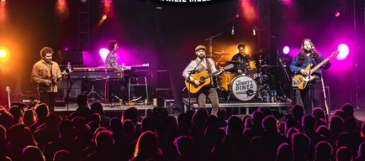

**Brahms and Strauss**

**Friday, September 19,** **2025,  7:30pm**

**Immerse yourself in an unforgettable evening of captivating music featuring the St. Louis Symphony’s Horn Thomas Jostlein, Grammy awarding winning soprano Christine Brewer, and virtuosic violinist Julia Sakharova and pianist Jennifer Judd.**

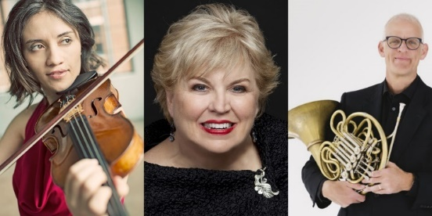

**Arianna String Quartet**

**Friday, October 17, 7:30pm**

**Enjoy an enchanting evening of music performed by this world-renowned group of musicians. Members of the Arianna String Quartet serve on the faculty at the University of Missouri-St. Louis. Pianist Jennifer Judd will join them in performing Dvorak’s Piano Quintet.**

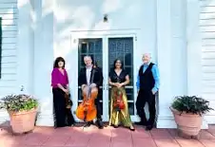

**St. Louis Wind Symphony**

**Friday, November 14, 2025, 7:30pm**

**Come hear the St. Louis Wind Symphony, an outstanding concert band composed primarily of talented musicians from Missouri and Illinois. The ensemble features a remarkable group of current and former music educators. Through their skillful performances and dedication to music education, the St. Louis Wind Symphony offers a unique and inspiring musical experience. The** nd65-member ensemble is staffed by musicians from across Illinois. 

**The Trombones of the Saint Louis Symphony**

**Friday, January 23, 2026, 7:30pm**

**Join us in welcoming The Trombones of the grammy award-winning Saint Louis Symphony. Enjoy this group of dynamic performers as they showcase the versatility and power of the trombone, delivering a program you won’t soon forget.**

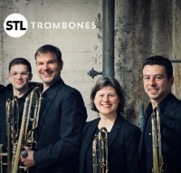

**Halen, Ranheim and Judd**

**Friday, March 6, 2026, 7:30pm**

**Celebrate the timeless music of Beethoven and Schubert in this extraordinary concert, featuring St. Louis Symphony Orchestra concertmaster David Halen and acclaimed SLSO cellist Bjorn Ranheim. Joined by pianist Jennifer Judd, they will deliver a performance that is sure to mesmerize and inspire.**

**Vince Varvel Quartet**

**Friday, April 24, 2026, 7:30pm**

**The Vincent Varvel Quartet, featuring Joel Vanderheyden on saxophone and electronics, Eric Warren on bass, Joe Meyer on drums, and Varvel on electric guitars, plays music that combines atmospheric electronica with deep grooves and captivating melodies along with exploration and improvisation.**

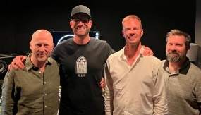

**Matinee Series**

**Chamber Music for Flute, Cello, and Piano**

**Friday, September 5, 4pm**

Featuring Dr. James Thompson, flute, Dr. Sara Edgerton, cello, and Mr. Paul Thompson, piano, this concert will present exciting and diverse repertoire from the Baroque to contemporary music.  Join us as this popular ensemble of family musicians returns to the ECC Matinee Series with a program of lovely chamber music!

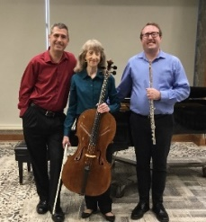

**Robert Satterlee Piano Recital**

**Friday, November 7, 2025, 4pm**

Pianist Robert Satterlee has developed a reputation as an accomplished and versatile solo recitalist and chamber musician.  He plays regularly throughout the United States, delighting audiences with his incisive and imaginative performances. Dr. Satterlee serves on piano faculty of Bowling Green State University.

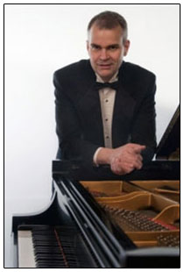

**Women of Note: Caccini, Strozzi & Leonarda**

**Friday, February 13, 2026, 4pm**

Early Music Missouri returns to ECC with a concert of Baroque music, all composed by Italian women. The concert features both sacred and secular vocal music from the early 17th Century by Barbara Strozzi and Francesca Caccini. Additionally, the ensemble will perform late 17th-century violin sonatas by Isabella Leonarda.

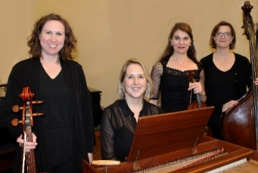

**Faculty Recital**

**Friday, March 27, 5pm Theater**

Join us for a faculty recital featuring the outstanding musicianship of our esteemed music faculty. Showcasing a diverse program that highlights their artistry and versatility, this performance offers a unique opportunity to experience the talent and passion that define our music department.

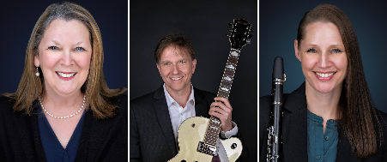

**Ensemble Series (all concerts begin at 7:00 pm in the theater unless otherwise noted)**

**Bands Concert-Tue October 7**

**ECC Choral Invitational Concert –Thu October 16**

**ECC Choirs Christmas Celebration – Fri December 5, Location TBA**

**Bands Concert Tue, December 2  
Band Concerts- Tue March 3  
ECC Choirs Jazz Cabaret – Tue March 10**

**ECC Choirs Concert- Fri May 1**

**POPS Concert- Fri, May 8, 6:00 PM POPS @ Washington Fairgrounds**

**Festivals**

**District Audition Preparation Workshop, September 6**

**Piano Sonatina and Violin Festival- Jan 31 and Feb 1  
East Central College Choral Festival -March 10**

**Palen Band Days- Thu, March 12th and Fri, March 13th   
MSHSAA Choir - 3/26/26  
MSHSAA Band - 3/27/26  
MSHSAA Solo/Ensemble - 3/28/26**

**Jazz Festival- Thu, April 23rd and Fri, April 24th**