**Save time and money at East Central College with a bit of practice at Learning Express Library**

Are you registered to take the COMPASS placement test at East Central College?   
The COMPASS placement test will evaluate your skills in English and Math.   
Your scores will result in placement in the correct English and Math courses at East Central College.

A bit of practice is all you may need to improve your skills and receive a higher score.   
Placing in a higher level course can save you time (not taking a lower level course)   
and money (no tuition for the lower level course).

**Learning Express Library is a free online practice test option.**

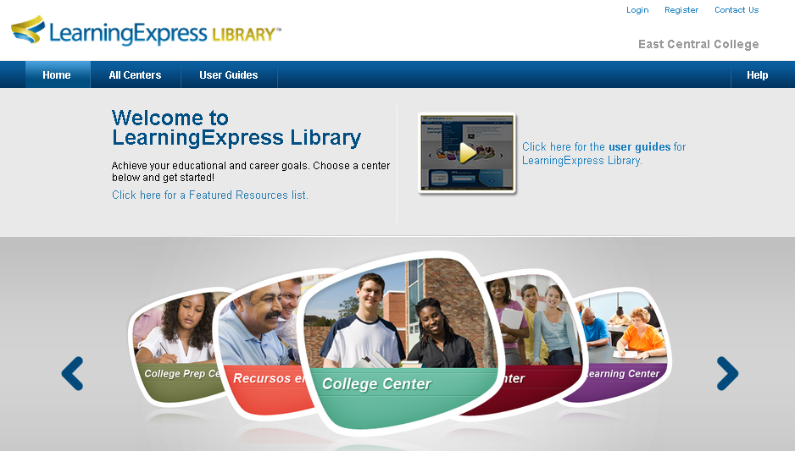

**Registration is free at any local library; East Central College, Scenic Regional & Washington Public Libraries.** After you create a free Learning Express Library account at a local library   
you will be able to access it from any internet location, including at home.

The practice test score is not reported to any college and can be retaken multiple times at your convenience.

Start at [www.learningexpresslibrary3.com](http://www.learningexpresslibrary3.com), sign in with your registered account created at any local library,   
select *College Center*, choose *Prepare for College Placement Exams*,   
select *COMPASS* (left column), and choose a test to get started.

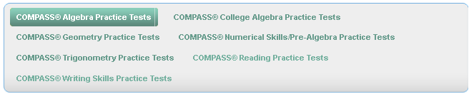

**Get started today by registering for a free Learning Express Library account at your local library.**