If a 2014 Federal Tax Return Transcript is requested for verification,

**You must complete one of the following**:

1. Use the **IRS Data Retrieval Tool** within the FAFSA on the web:
   1. Go to **FAFSA.gov**, log in to your FAFSA record, and select **Make FAFSA Corrections**.
   2. Navigate to the **Financial Information** section of the form, **Link to the IRS**, and download your tax information.
   3. If you need more information about when, or how to use the IRS Data Retrieval Tool see your financial aid administrator.
2. Electronically request an official **2014** **Tax** **Return Transcript** be mailed to you:
   1. Go to [*www.irs.gov*](http://www.irs.gov) and select **Get a Tax Transcript by Mail.**
   2. Then select **Get Transcript by Mail** and enter your information.
   3. Select **Return Transcript** for Type of Transcript.
3. Complete a **Request for Transcript of Tax Return Form** **4506-T** (available under Financial Aid Forms at [www.eastcentral.edu](http://www.eastcentral.edu)) and fax to (816) 292-6102 or mail to the address on the form.
4. Visit a local IRS office to obtain a copy in person:

|  |  |  |  |
| --- | --- | --- | --- |
| CHESTERFIELD | 1122 Town and Country Commons  Chesterfield, MO 63017 | Monday-Friday  8:30am – 4:30pm  (Closed for lunch 12:30-1:30) | (314) 612-4002 |
| EARTH CITY | 111 Corporate Office Dr.  Earth City, MO 63045 | Monday-Friday  8:30am – 4:30pm | (314) 612-4002 |
| JEFFERSON CITY | 3702 W. Truman Blvd.  Jefferson City, MO 65109 | Monday-Friday  8:30am – 4:30pm  (Closed for lunch 1:00-2:00) | (573) 635-6827 |
| ST. LOUIS | 1222 Spruce St.  St. Louis, MO 63103 | Monday-Friday  8:30am – 4:30pm | (314) 612-4002 |

1. **If you were not required to file taxes**:   
   In place of a tax transcript, you must provide a completed **4506-T** (available under Financial Aid

Forms at [www.eastcentral.edu](http://www.eastcentral.edu)). If you earned income from working, you must provide both a

completed **4506-T** and a copy of all **W2’s.**



**A copy of your**

**tax return cannot be accepted for the purpose of verification.**

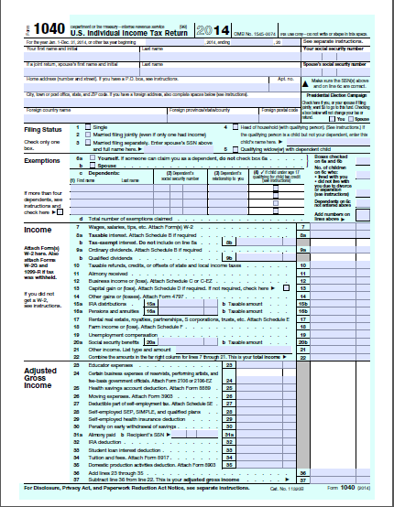 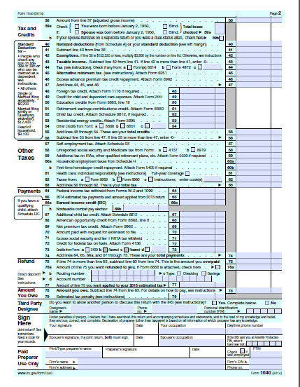

**Upon receipt of your 2014 Tax Return Transcript**, please email ([finaid@eastcentral.edu](mailto:finaid@eastcentral.edu)), mail, or fax to our office (636) 583-6651 along with any other requested documents and include the student’s ID or Social Security number on each document.